Anti Riot Shield With Pepper Spray & Blinding LED

Riots are today a part of every civilized society. Disagreement for government decisions, religious intolerance, events, hateful content etc are some of the many reasons that can easily spark riots. To handle a riot police, army must be able to pacify/disperse the crowd without harming them. This is the major problem with riot control situations, rioters do not listen to any announcements and need to be handled with force which leads to injuries or even deaths of rioters as well as police.
To solve this issue we here design a smart anti riot shield that allows police personnel repell/arrest rioters without harming themselves or the rioters. The smart shield makes use of 2 non injurious techniques along with few other features for this purpose for this purpose.
- Pepper Spraying for blinding rioters who come close to attacking the police
- LED Blinding Lights to blind attackers who attempt to throw stones on the police
- Lightweight Aluminium shield with Kevlar coating for bulletproofing protection from stones.
- Slot for viewing the rioters safely through the shield.
The shield is a one arm light weight shield made up of a aluminium and Kevlar coating for a lightweight single arm protection against stones and bullets. Also it leaves the other arm free to hold a baton/shocker/tear gas launcher.
The shield is integrated with a push button trigger to spray pepper spray onto rioters who come close enough to hold the shield. This sprays pepper spray which leads to eye etching and repells them. For stone pelters who throw stones from a distance, the shield includes another trigger that enables led blinders.
The high power led’s are specifically made blinding lights that can blind them for a couple of minutes making them unable to throw stones or target personnel. This allows cornered police personnel to escape from a bunch or rioters as well as it can be used to blind rioters from a distance and them arrest them as they cant see for a couple of minutes.
Thus the lightweight anti riot shield is a smart combination of blinders, pepper spray and metal + Kevlar protection to provide a solution to riot control.

Approx Size: 650 x 400 x 20mm

Components
- Aluminium Frame
- Kevlar Coat
- High Power LED
- Battery
- Heatsink
- Pepper Spray Tank
- Trigger Buttons
- Handle & Arm Strap
- Electrical Setup
- Wirings
- Piping
- Supporting Frame
- Mounts & Joints
- Screws and Bolts

Applications
- Riots

Advantages
- Light Weight Design
- Bulletproof and Stone Proof Design
- One arm mounted
- Pepper Spray Repellent for Close Encounters
- Blinding LED’s for Stone Pelters
- Non Injurous Solution

Disadvantages
- Needs Battery To Operate
- Cannot Stop High Caliber Bullets

Block Diagram
Front View
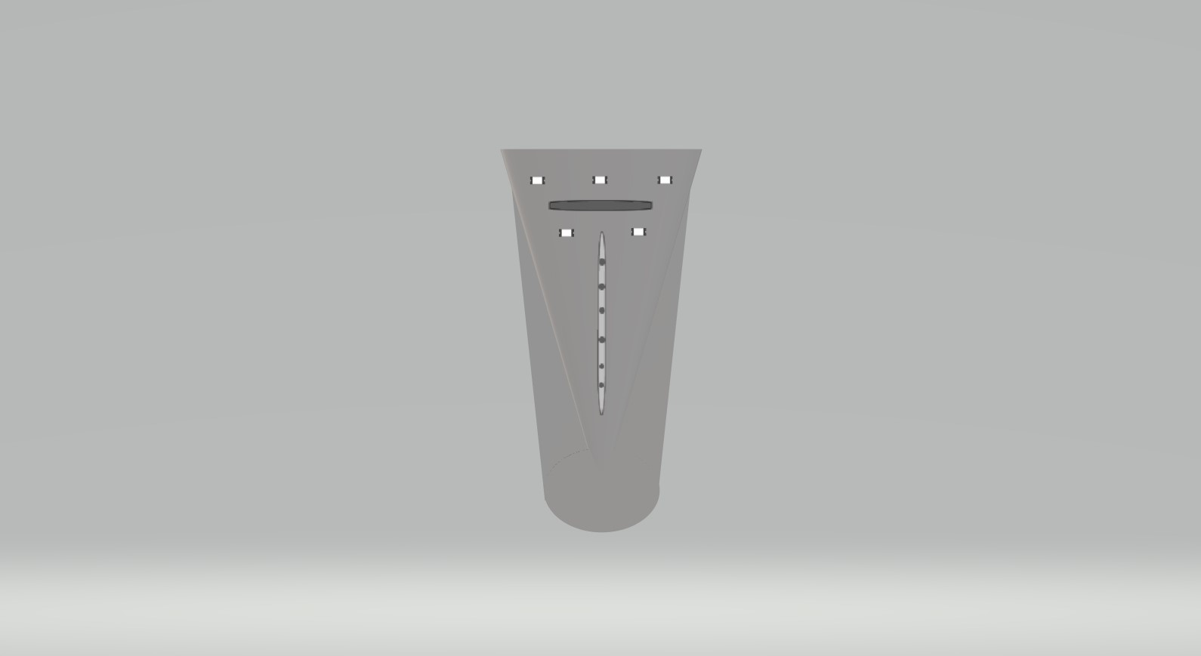
Side View
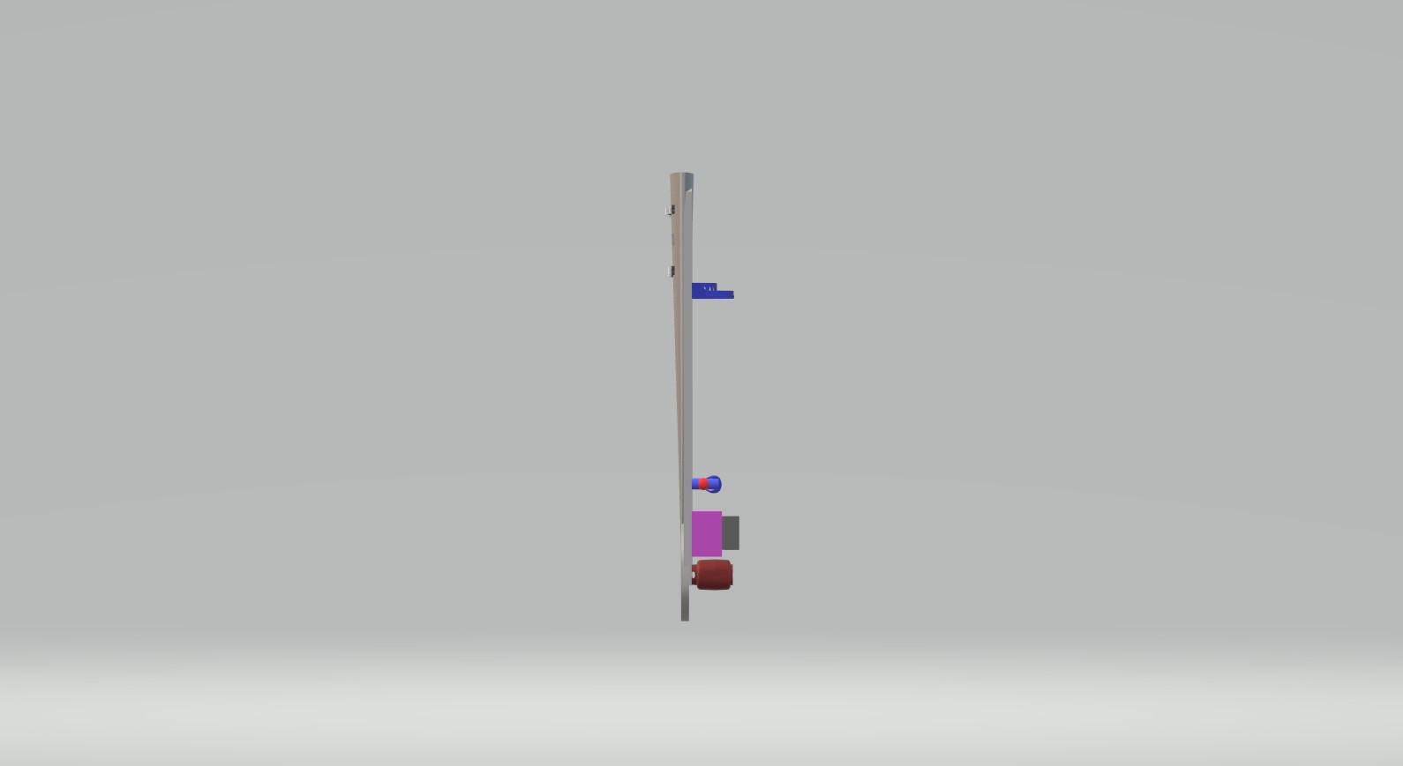

3d View

